| **Course: CSE 462 - Network Analysis and Design**  **LAB 4 – Routing Configuration** |
| --- |

| **Group ID** | *Group 1* |
| --- | --- |
| **Student Name** | **Ngô Quang Khiêm,**  **Hà Quang Minh,**  **Lê Quốc Khánh** |
| **Final Score** |  |

**Lab Exercise Submission**

Students are responsible for submitting the required working files by the stated deadline for full marks. Late submissions are NOT accepted.

**Objective:** This lab is to guide you how to work with Routers and routing protocols.

**NOTE:** *Students should read the guideline carefully before conducting Lab experiments.*

**🙡 - Good luck - 🙣**

**TASK 1 – CONFIGURE STATIC ROUTE**

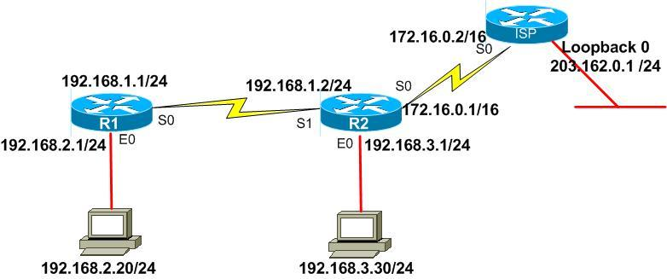

**Step 1: Configure basic parameters for Routers R1, R2, ISP**

- Set **hostname, banner**

- Set enable pass as **“eiu@123”**

- Configure and set password for **SSH** sessions**,** password is “cisco@123”

**R1:**

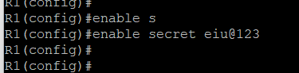

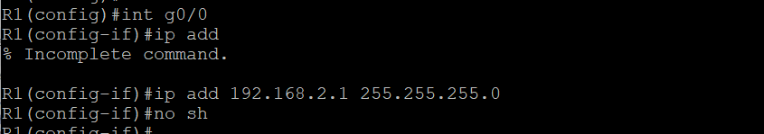

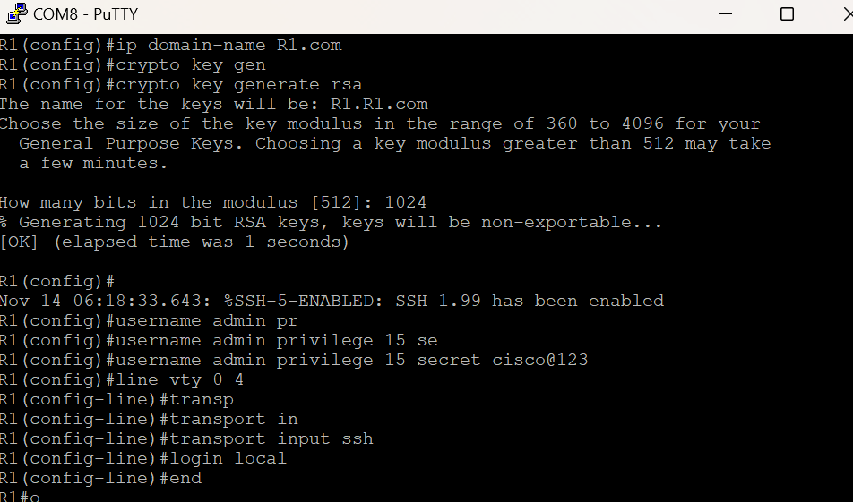

**R2:**

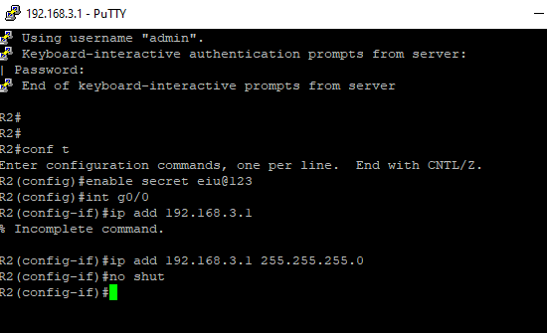

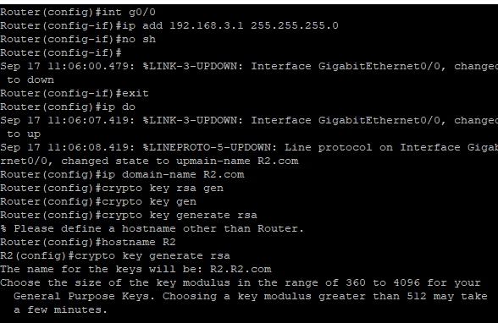

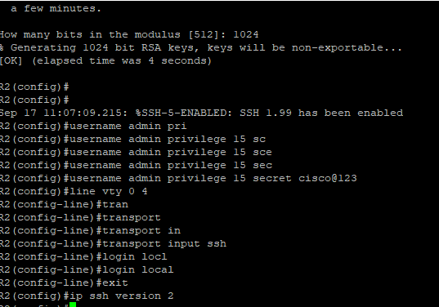

**ISP:**

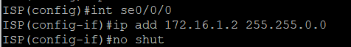

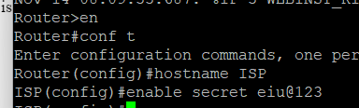

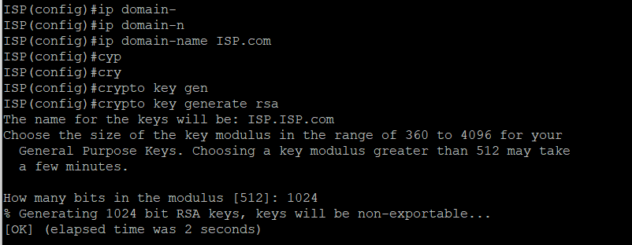

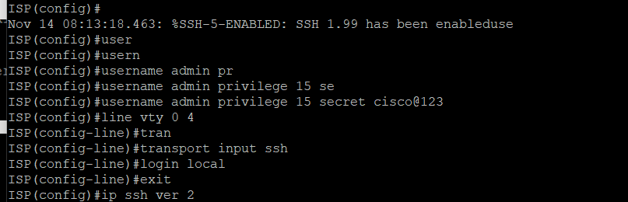

**PC1:**

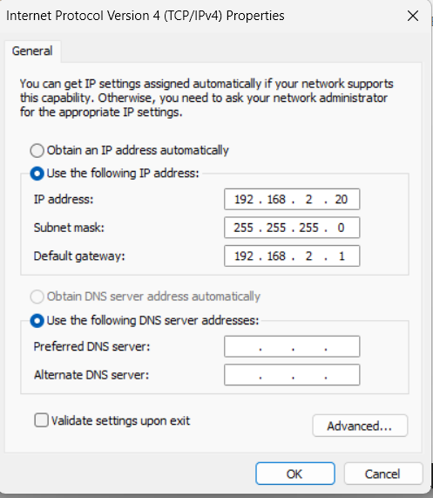

**PC2 : 192.168.3.30 /24**

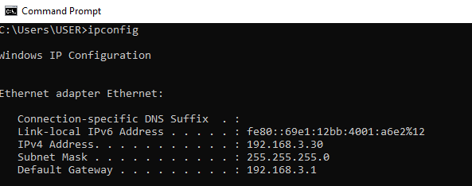

**Step 2: Assign IP addresses to Routers and PCs**

**Note**: *On the ISP, create a loopback interface (virtual interface - used to test results).*

ISP(config)#**interface loopback 0**

ISP(config-if)#**ip address 203.162.0.1 255.255.255.0**

*There is no need to type the* ***no shutdown*** *command for this interface.*



**Step 3: Configure static routes for R1**

From the network model above, it must be determined **which networks are not directly connected to R1**. From there, execute the following **static route commands**:

R1(config)#**ip** **route 192.168.3.0 255.255.255.0 192.168.1.2**

***Do the same for other networks***

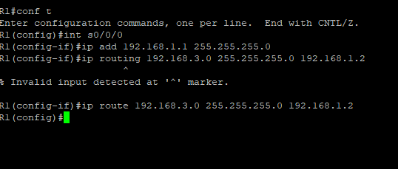

**Step 4: Configure static routes for R2**

Must determine which **networks are not directly connected to R2**, then execute the following static route commands:

R2(config)#**ip route 192.168.2.0 255.255.255.0 192.168.1.1**

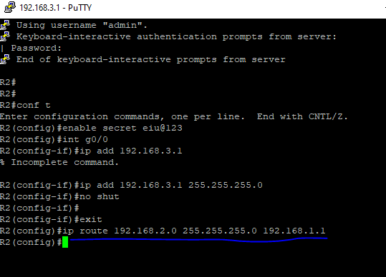

According to the figure, because **R2 acts as a Gateway** for the Networks on the left (R1) to go to the ISP service provider, we can use the following **default route command:**

R2(config)#**ip route 0.0.0.0 0.0.0.0 serial 0**



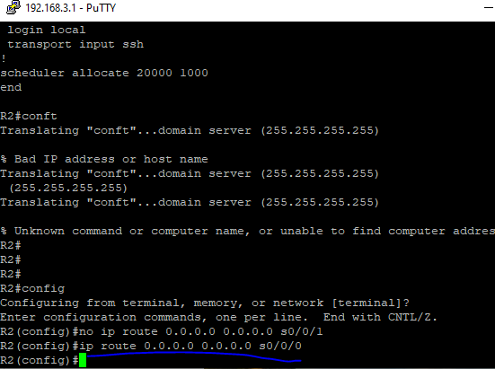

**Step 5: Configure static routes for ISP Routers**

From the figure, you must determine which **networks are not directly** connected to the ISP Router. From there, execute the following **static route commands***:*

ISP(config)#**ip route 192.168.2.0 255.255.255.0 172.16.0.1**

ISP(config)#**ip route 192.168.3.0 255.255.255.0 172.16.0.1**

ISP(config)#**ip route 192.168.1.0 255.255.255.0 172.16.0.1**

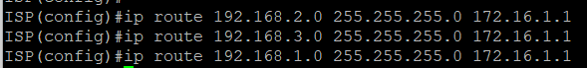

**Step 6: Check the routing tables on the routers, and other parameters:**

**Show ip protocol**

**Show ip int brief**

**Show ip route**

**ISP:**

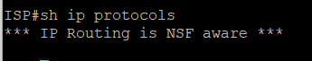

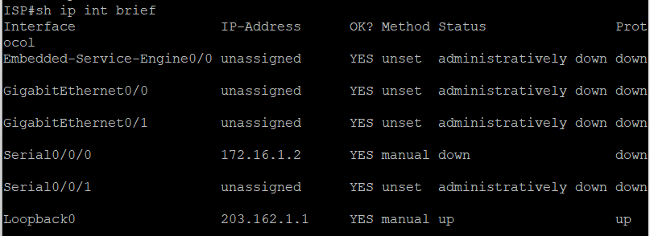

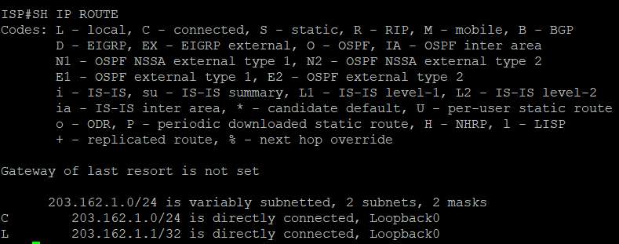

**R1:**

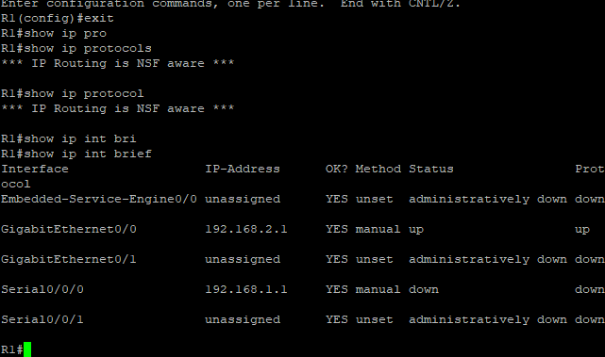

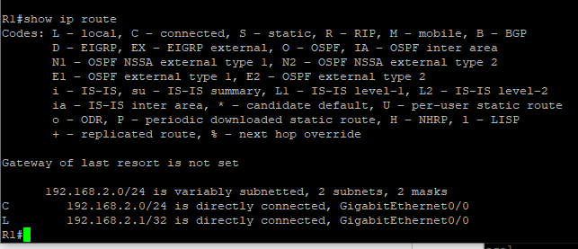

**R2:**

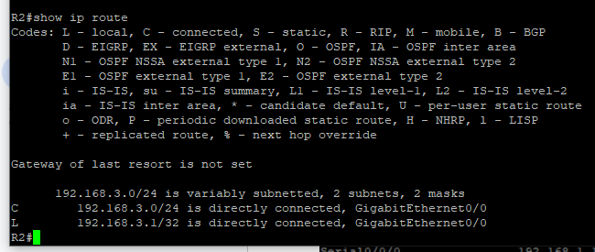

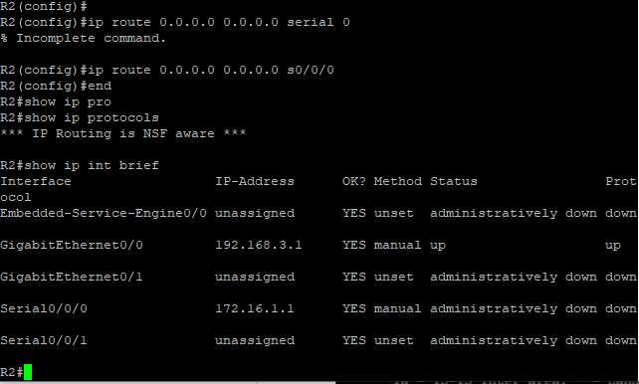

**Check connection between devices in networks with the following commands:**

1.Use the **Ping command** to check the connection between PCs.

**PING PC2 → PC1 :**

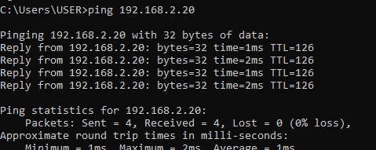

**PING PC1 → PC2:**

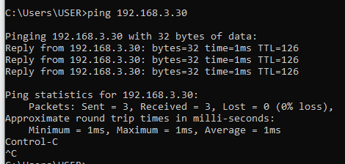

2. Use the **Traceroute command** to check the connection between Routers.

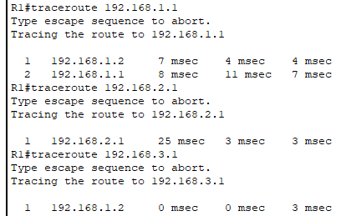

3. Use the **Telnet command** to check the application layer between PC and Router.

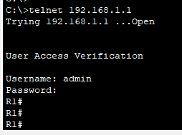

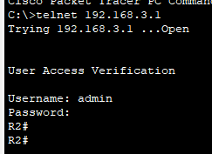

**TASK 2 – BROADCAST ROUTING INFORMATION BETWEEN RIP AND STATIC ROUTE**



**Note:** *Make device connections according to the above model. You can delete the old configuration before doing this Lab.*

**Step 1: Make connections according to the diagram and configure basic parameters for the Switch.**

- Set **hostname, banner**

- Set enable pass as **“eiu@123”**

- Configure and set password for **SSH** sessions**,** password is “cisco@123”

**Step 2: Configure IP for switches and PCs**

**Step 3: Configure RIP dynamic routing protocol for R1, R2**

R1(config)#**router rip**

R1(config-router)#**network 192.168.1.0**

R1(config-router)#**network 192.168.2.0**

***Similar configuration for router R2***

**R1:**



**R2:**

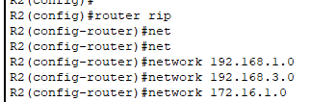

**Step 4: Configure static routes for ISP Routers**

The **ISP router** acts as **a service provider** for the internal network system R1 and R2. Due to security requirements, the ISP router *does not implement any dynamic routing protocols* with the internal network. Therefore, use **static route with internal network R1, R2.**

ISP(config)#**ip route 192.168.1.0 255.255.255.0 172.16.0.1**  
ISP(config)#**ip route 192.168.2.0 255.255.255.0 172.16.0.1**  
ISP(config)#**ip route 192.168.3.0 255.255.255.0 172.16.0.1**



**Step 5: Check the connection between networks:**

From **PC 192.168.2.20 on R1's LAN**, perform a ping command to the following addresses:

**PC1_C:\ping 192.168.1.2 🡪 must be successful!!**

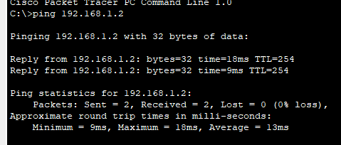

**PC1_C:\ping 192.168.3.1 🡪 must be successful!!**

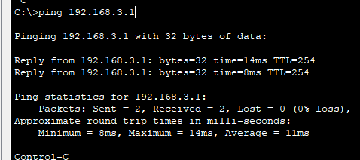

**PC1_C:\ping 172.16.1.1**

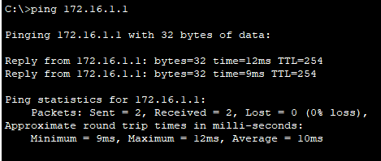

**PC1_C:\ping 203.162.0.1 ???**

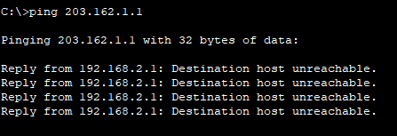

On 2 Routers **R1 & R2**, execute the **show ip route** command to see if any neighboring networks have been learned through the **RIP** protocol. If not, check the configuration, cable connection, etc.

**#show ip route**

**Networks learn through the RIP protocol?**

**R1:**

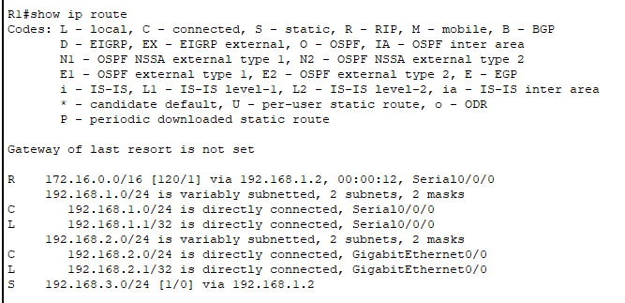

**R2:**

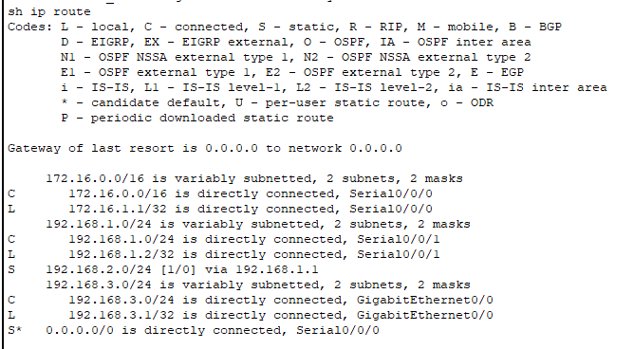

Similarly, from PC 192.168.3.30 on **R2's LAN**, ping the interface addresses. However, everyone cannot ping the ISP, especially the loopback interface address 203.16.0.1.

**Step 6: Configure Default information broadcast to R2**

Router **R2** in the diagram acts as the **Gateway for R1** and the Networks on the left of R2. Therefore, in order for these networks to go outside the internet, **R2** must take on the function of broadcasting Default information to internal networks.

R2(config-router)#**default-information originate**

R2(config-router)#**exit**

R2(config)#**ip route 0.0.0.0 0.0.0.0 172.16.0.2**

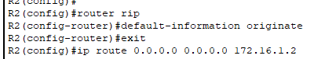

After configuring this command, execute the **show ip route** command on the Routers to see how the routing table has **changed**?

**R1:**

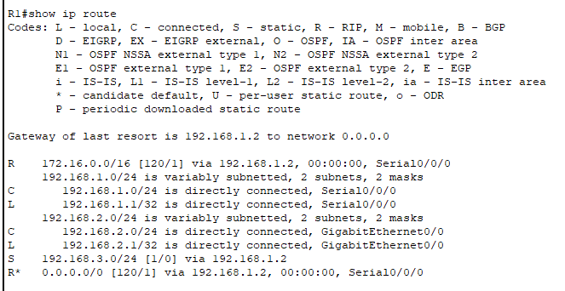

**R2:**

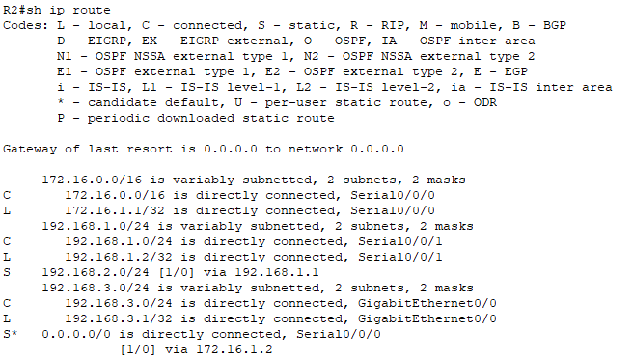

Ping from PC to ISP loopback interface to check:

**PC1_C:\ping 203.162.0.1 🡪 must be successful!!**

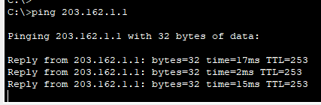

**Step 7: Save configuration to NVRAM**

ISP#**copy running-config startup-config**

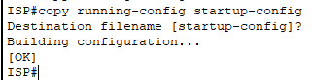

R1#**copy running-config startup-config**

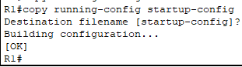

R2#**copy running-config startup-config**

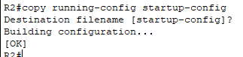

**Commands used to check configuration information:**

**#Show ip protocol**

**#Show ip int brief**

**#Show ip route**

**#clear ip route \***

**R1:**

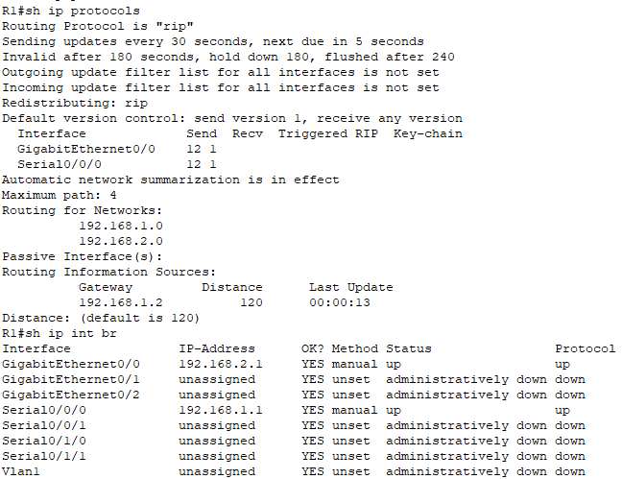

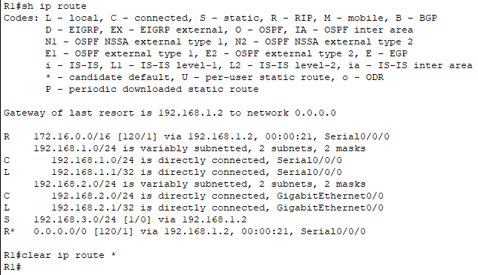

**R2:**

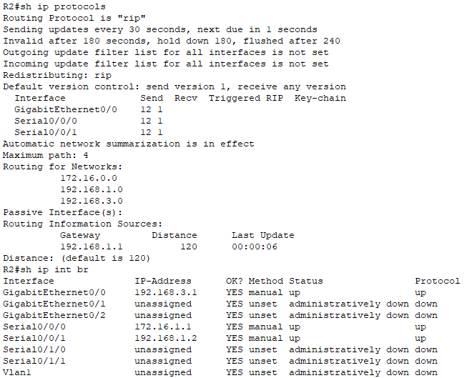

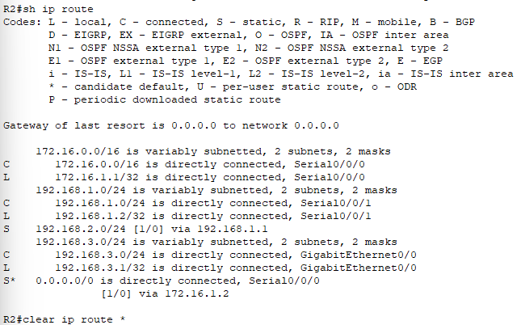

**ISP:**

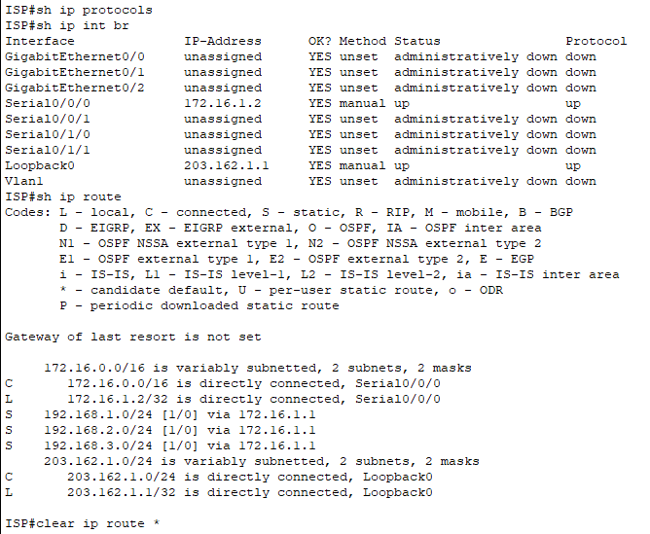

**TASK 3 – BROADCAST ROUTING INFORMATION BETWEEN OSPF AND STATIC ROUTE:**



**Step 1 & 2: Configure basic parameters for 3 Routers and assign IP addresses to interfaces**

**R1:**

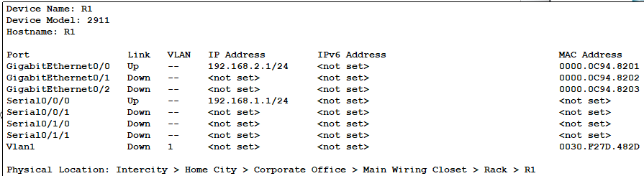

**R2:**

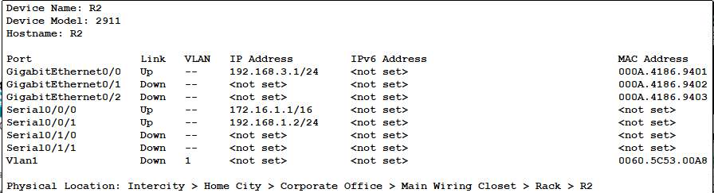

**ISP:**

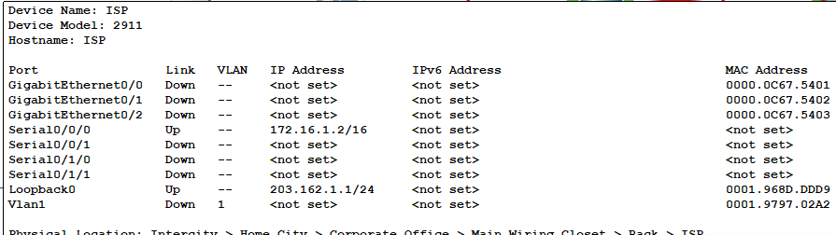

**Step 3: Configure OSPF on R1 and R2**

R1(config)#**router ospf 1**

R1(config-router)#**network 192.168.1.0** **0.0.0.255 area 1**

R1(config-router)#**network 192.168.2.0 0.0.0.255 area 1**

***Do the same for R2***

**PC1:**



**PC2:**

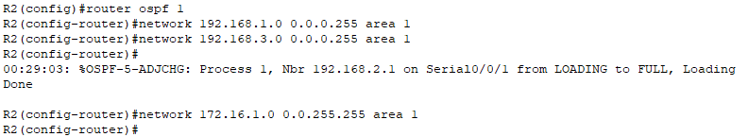

**Step 4: Configure static routes for ISP Routers**

**The ISP router** acts as a service provider for **the left network model (R1-R2).** Therefore, security on the **ISP** is necessary, so the **ISP** *router does not use dynamic routing protocols but uses static routing.*

**Configure static routing on the ISP router to the networks of routers R1 and R2.**

ISP(config)#**ip route xxx . . .**



**Step 5: Check connection between networks:**

On **2 Routers R1 & R2**, execute the **show ip route** command to see if any neighboring networks have been learned through the **OSPF protocol.** If not, then check the configuration, cable connection, etc.

***Which Networks Learn Through the OSPF Protocol?***

**R1:**



**R2:**

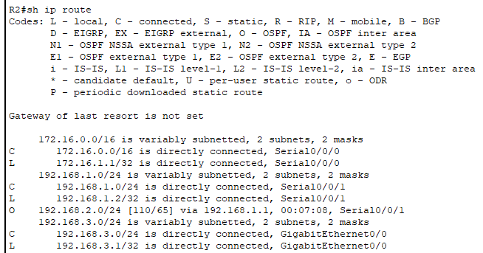

From PC1 192.168.2.20 on R1's LAN, perform a ping command to the following addresses:

**PC1_C:\ping 192.168.1.2 🡪 must be successful!!**

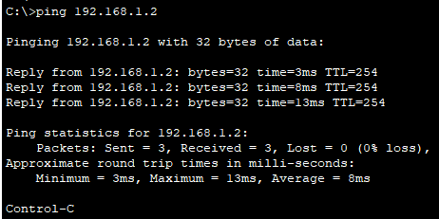

**PC1_C:\ping 192.168.3.1 🡪 must be successful!!**

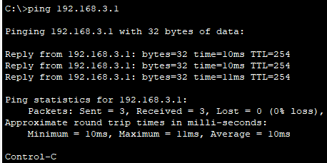

**PC1_C:\ping 172.16.0.2**

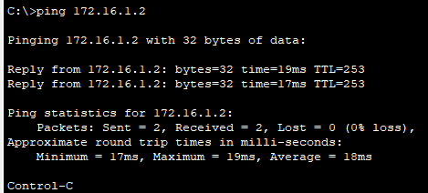

**PC1_C:\ping 203.162.0.1 ???**

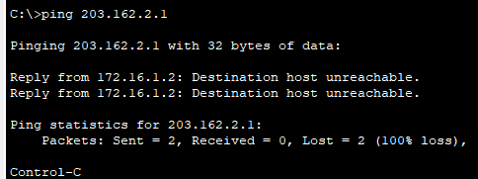

Similarly, from **PC 192.168.3.30** on **R2's LAN**, ping the interface addresses. However, everyone cannot ping the ISP, especially the **loopback interface** address **203.162.0.1**.

**Step 6: Configure Default information broadcast to R2**

**R2** in the diagram acts as the **Gateway for R1** and the Networks on the left of R2. Therefore, in order for these networks to go outside the internet, *R2 must take on the function of broadcasting Default information to internal networks*.

R2(config-router)#**default-information originate**

R2(config-router)#**exit**

R2(config)#**ip route 0.0.0.0 0.0.0.0 172.16.0.2**

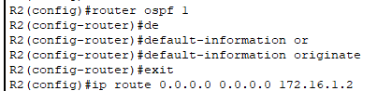

***After configuring this command, execute the show ip route command on the Routers to see how the routing table has changed?***

R1:

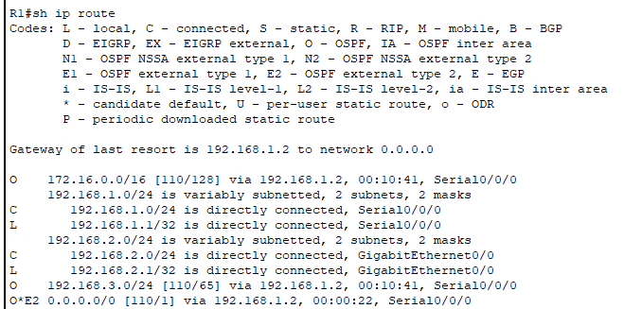

R2:

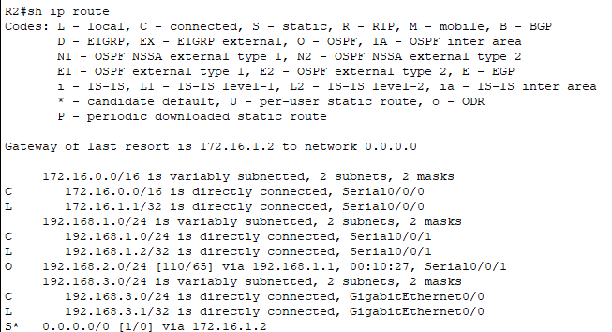

*Meaning of* ***default-information originate*** *command?*

This command is typically done to inform other routers about how to reach external networks or the internet.

**Step 7: Answer the question**

***- How long does the OSPF protocol periodically send update information?***

OSPF does not send periodic updates like RIP. Instead, OSPF uses LSAs and only sends updates when there is a topology change in the network. However, OSPF does periodically refresh its LSAs every 30 minutes (1800 seconds) by default.

***- What is the administrative distance value of OSPF?***

The administrative distance of OSPF is 110. This value determines the trustworthiness of OSPF routes compared to routes learned from other protocols

***- How many networks are learned by the OSPF protocol on Router R1?***

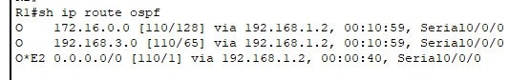

**Step 8: Configure password authentication mechanism in OSPF**

**On Router 1:**

R1(config)#**interface serial 0**

R1(config-ip)#**ip ospf authentication-key eiu@123**

R1(config-ip)#**exit**

R1(config)#**router ospf 1**R1(config-router)# **area 1 authentication**

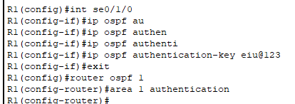

***- Comment on what changes in the routing table between the 2 Routers?***

R1:



R2:



***- Perform ping command between hosts, is it successful?***

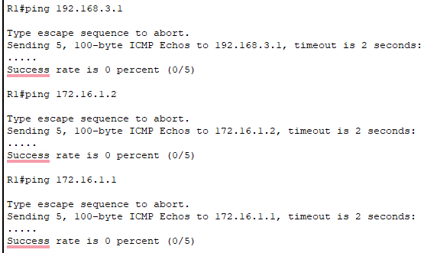

***- Why?***

When configuring OSPF authentication, routers in the same area 1 must use the same authentication-key to exchange OSPF information.

If another router in area 1 has not been configured for authentication or has a different key (eiu@123), OSPF cannot establish a neighbor relationship, resulting in a failure to ping because the routing table is not updated.

***- How many routes (subnets) are learned by the OSPF protocol on Router R1?***



**On Router 2:**

R2(config)#**interface serial 1**

R2(config-ip)#**ip ospf authentication-key eiu@123**

R2(config-ip)#**exit**

R2(config)#**router ospf 1**R2(config-router)# **area 1 authentication**

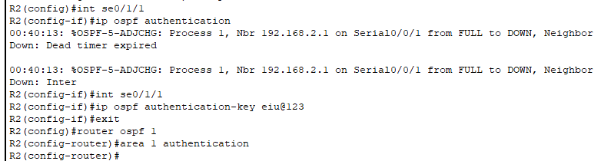

***- Comment on what changes in the routing table between the 2 Routers?***

R1:

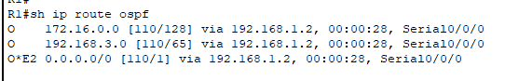

R2:



***- Perform ping command between hosts, is the result successful?***

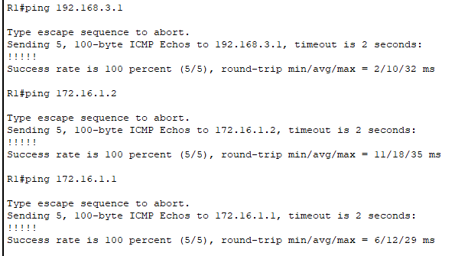

***- If ping is not successful, recheck the configuration above.***